# **Medical Data Interpretation Report**

### **Overview**

This report summarizes insights from an analysis of medical costs and BMI trends across various demographics, including gender, age, weight class, smoking status, and geographic regions in the U.S. The goal is to identify key cost drivers and patterns to inform public health strategy, insurance design, and preventive care initiatives.

### **1. Key Findings**

#### **Medical Costs by Weight Class**

* **Overweight and obese individuals** account for a **significant share** of medical costs. The **obese category** in particular drives a substantial cost burden with a total medical cost of ***$17,293,312.38,*** second only to the **"slightly above normal weight"** class which surprisingly incurs the highest total cost of ***$53,637,401.36,*** potentially due to volume or borderline risk factors.

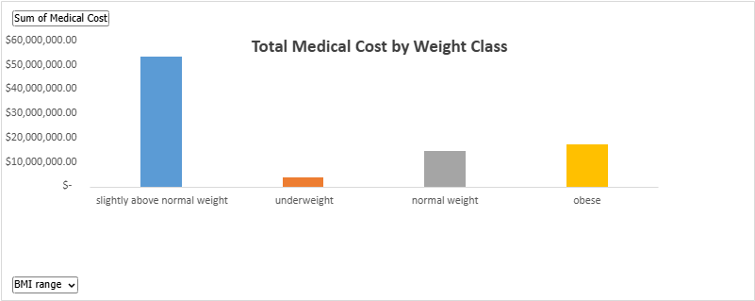

#### **BMI Trend by Age**

* BMI values generally **fluctuate between 26 and 29**, with a **mild upward trend** as age increases.
* Notable BMI spikes are seen around ages **32, 43, and late 50s**, suggesting mid-life weight gain could be a cost driver.

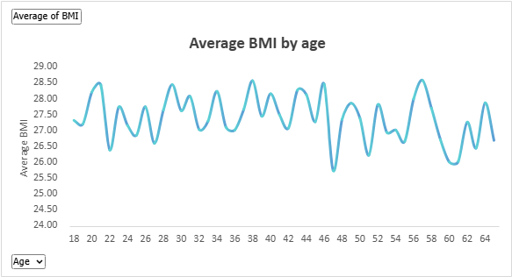

#### **Medical Cost by Region**

* **Northeast and Southwest** regions incur the **highest medical costs**  , while the **Northwest** records the lowest.
* Regional cost differences may reflect disparities in healthcare access, lifestyle, or policy.

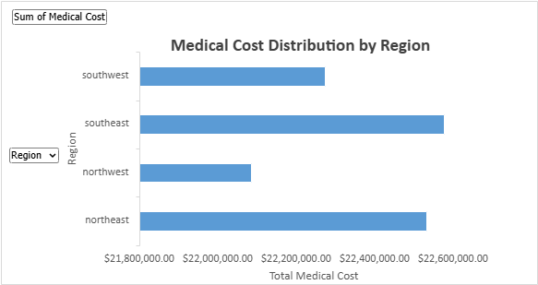

#### **Medical Costs by Gender**

* **Females incur higher total medical costs** compared to males, likely reflecting higher utilization (e.g., reproductive health, longevity) rather than higher per capita costs.

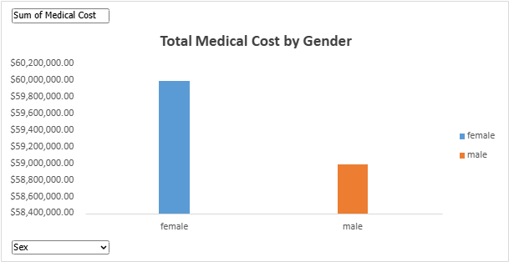

#### **Average BMI by Gender & Age Group**

* BMI is **slightly higher in females** across most age groups.
* The **age group 41–59** shows the **highest average BMI** for both genders, aligning with observed increases in cost burden for this segment.

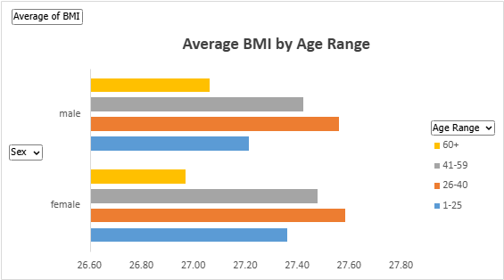

#### **Costs by Age Group**

* The **41–59** age group accounts for the **highest medical costs (42%)**, followed by the **26–40** group (29%).
* Older adults (60+) account for only **14%** of total costs, which could imply lower utilization due to Medicare or fewer costly interventions.

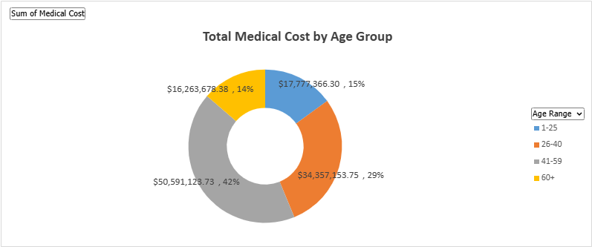

### **2. Insights & Implications**

* **Preventive interventions targeting midlife adults** (26–59) could yield the greatest cost savings.
* Programs to **address obesity** and manage weight through early adulthood may significantly reduce long-term healthcare costs.
* **Regional disparities** suggest an opportunity for localized public health efforts, especially in high-cost zones like the Northeast and Southwest.
* The data shows **gender-specific patterns** that may require tailored health services for women, especially in peak reproductive and post-reproductive age windows.

### **3. Recommendations**

1. **Target Obesity Reduction**: Launch community-based wellness initiatives aimed at reducing obesity in the 26–59 age range.
2. **Regional Programs**: Develop region-specific health campaigns in high-cost areas to reduce preventable conditions.
3. **Gender-Based Preventive Health**: Encourage insurers and employers to support women's health screenings and lifestyle coaching, particularly in the 30–50 age range.
4. **Longitudinal BMI Monitoring**: Introduce tools that allow individuals to track BMI trends over time to catch early warning signs.